Android Weather App

**Department: CSE**

**Members Roll**

**Adrija Mukherjee 48**

**Meghanto Majumder 42**

Index

**Topics Page**

Introduction 3

Design & Layout 4

Conclusion 6

References 6

Introduction:

SCOPE :

The weather app has been implemented on android studio version 3.4.

· The application comes with features such as viewing the current weather conditions and forecasts of the present day and the next two days.

· The temperature reflects change in the colour gradient of the layout, i.e., warm temperatures show warm colours.

· The weather conditions available for view include temperature(in Celsius only) , wind speed, humidity and atmospheric pressure.

· The app can be used to know the current weather of about 2,00,000

cities in the world, as supported by OpenWeatherMap API.

The app is a light-weight application (consuming only about 2.67 MB), since it has limited functionalities.

TECHNOLOGIES USED

· ANDROID STUDIO : · **Android Studio** is an integrated development environment (IDE) used for the weather application. It provides Gradle-based build support and a layout editor that allowed to drag-and-drop UI components and option to preview layouts.

· Volley is a tool for handling HTTP requests. The ‘getJsonObject()’ and ‘getJsonArray()’ method for handling the response received from the API. It is very easy to use and implement as we do not have to create Java classes for handling the URLs.

· OPEN WEATHER MAP API Current weather as well as forecasts are for five days available at an interval of three hours. The weather data could be fetched for over 3700+ cities. The information is available in metric and imperial system.

ANDROID WIDGETS AND LAYOUTS

* Image View
* TextView
* Button
* PlainText
* TableLayout
* LinearLayout
* ConstraintLayout

Design & Layout

* The weather app is designed keeping in mind the ease of use for everyone. The colour of the layout changes as per the temperature of that region. Higher temperature increases the red component and lower temperature increases the blue component.
* The first activity displays the temperature of a default location - Kolkata,IN. The temperature at that time is displayed first.
* The entire layout is very simply done , based on the concept of linear layouts and simple Text Views and Image Views have been used as containers. Then we have used a table layout to display the current pressure, humidity and wind speed.
* The user has to liberty to choose any one of the cities provided by the OpenWeatherMap API for viewing the forecast and present weather conditions. The option of choosing locations has been implemented using a menu resource .xml file along with an Alertdialog.
* The dates and timings were in accordance to “GMT”. Hence the date was parsed according local time zone of the city as selected by the user.

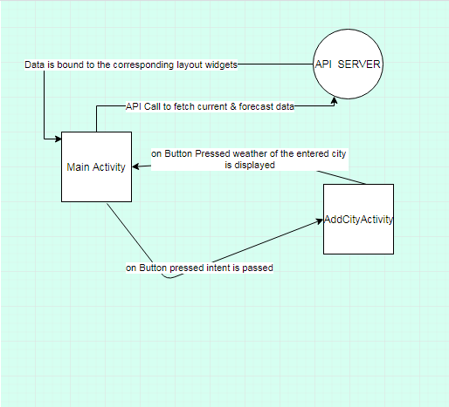

Basic Layout of the application

Conclusion

The application is a basic one, with very minimal functionalities. The app meets all of the said requirements. But it has its limitations as it does not handle wrong city names very well. It still has to be improved to a large extent and has reached a very preliminary stage in terms of its development.

References

* <https://openweathermap.org/guide#how>
* <https://openweathermap.org/weather-conditions>
* <https://icons8.com/icon/set/weather/color>
* [https://uigradients.com](https://uigradients.com/)
* [https://stackoverflow.com](https://stackoverflow.com/)
* <https://www.youtube.com/watch?v=y2xtLqP8dSQ>
* <https://developer.android.com/reference/androidx/packages>